Deployment & Execution Guide –
OCT v1.0.0

Introduction 2
Terminology 2
Parameters 2
Objects to deploy 2
1.1 Create Directories: 2
1.2 Deploy Scripts 3
1.3 Create Tables 3
1.4 Meta insert SQL scripts 3
1.5 Functions 4
1.6 Reporting framework 4
1.7 Contexts 5
1.8 Workflows 5
Executions: 6
1.1 Execution of the export workflows: 6
1.2 Manual step: 10
2.3 Execution of comparision workflow 11
****END**** 12

Introduction
The OCT stand for Objects Comparison Tool. It is designed to compare objects across different tiers. It systematically compares all database and PBA server objects, generating a CSV file that lists any objects with differences between the two tiers.

Terminology
- ODO - On Dev Only (EPC5 example: rich-pba-003-rv):
In this document the objects which needs to be deployed on Dev only has referred with ODO
- OAE – On ALL Environment (The environments for which object comparison is required)
In this document the objects which needs to be deployed on all the environment has referred with OAE
NOTE: All OCT objects should be deployed on the DEV environment. For upper tiers, only the objects available in the OAE folder should be deployed. The source location and deployment details for each object are specified below. Also, please follow the sequence while deploying objects as mentioned below.

Parameters
Following Parameters needs to be replaced with the Path specific to OE.
- PBARootPath Example: /F/Ford/FRDCornerstone/1.0.0.0
- PBAEPORootPath Example: /F/Ford/FRDCornerstone/EPO
- PATH_COMMON_SCRIPT Example: /app/script

Objects to deploy

Create Directories:
- Create below directories on DEV PBA server (rich-pba-003-rv)- ODO:
- /bin/mkdir -m 6777 -p (PBAEPORootPath)/OCT
- /bin/mkdir -m 6777 -p (PBAEPORootPath)/OCT/TIER1
- /bin/mkdir -m 6777 -p (PBAEPORootPath)/OCT/TIER2
Example:
- /F/Ford/FRDCornerstone/EPO/OCT
- /F/Ford/FRDCornerstone/EPO/OCT/TIER1
- /F/Ford/FRDCornerstone/EPO/OCT/TIER2

- Create below directories on each PBA server- OAE:
- /bin/mkdir -m 6775 -p (PBARootPath)/(PATH_COMMON_SCRIPT)/OCT
Example: /F/Ford/FRDCornerstone/1.0.0.0/app/script/OCT

1.2 Deploy Scripts
1.2.1 oct_FileCount.sh - ODO
  - Place this shell script file on DEV only at: (PBAEPORootPath)/(PATH_COMMON_SCRIPT)/OCT
Ford Example: /F/Ford/FRDCornerstone/1.0.0.0/app/script/OCT
  - Source code Location: \OCT_v1.0.0\ODO\scripts\linux\oct_FileCount.sh

    - oct_script_export.py - OAE
  - Place this python file on each PBA server at: (PBAEPORootPath)/(PATH_COMMON_SCRIPT)/OCT
Ford Example: /F/Ford/FRDCornerstone/1.0.0.0/app/script/OCT
  - Source code Location: \OCT_v1.0.0\OAE\script\linux\oct_script_export.py

Please set permission as 775 for both these scripts in all environments.

Create Tables
1.3.1 pub_work.oct_ddl_tier1 – ODO
  - Execute oct_ddl_tier1.sql script on pub work on DEV.
  - Source Table script Location: \OCT_v1.0.0\ODO\tables\oct_ddl_tier1.sql

    - pub_work.oct_ddl_tier2 – ODO
  - Execute oct_ddl_tier2.sql script on pub work on DEV.
  - Source Table script Location: \OCT_v1.0.0\ODO\tables\oct_ddl_tier2.sql

    - bl.bl_sbs_report_meta – OAE
- Compile bl_sbs_report_meta.sql file on on all tiers in bl schema (if this table doesn’t exist in your environment).
- Table script: \OCT_v1.0.0\OAE\tables\bl\bl_sbs_report_meta.sql

1.3.4 bl.bl_sbs_oct_meta_tables – OAE
  - Execute bl_sbs_oct_meta_tables.sql script on all tiers in bl schema.
  - Source Table script Location: \OCT_v1.0.0\OAE\tables\bl\bl_sbs_oct_meta_tables.sql

Meta insert SQL scripts
1.4.1 oct_bl_sbs_report_meta_export.sql – OAE
  - Compile above sql script on every environment in bl schema.
  - Script location: \OCT_v1.0.0\OAE\script\database\bl\oct_bl_sbs_report_meta_export.sql

1.4.2 oct_bl_sbs_report_meta_comparision.sql – ODO
  - Compile above sql script on DEV in bl schema.
  - Script location: \OCT_v1.0.0\ODO\scripts\database\bl\oct_bl_sbs_report_meta_comparision.sql
1.4.3 oct_dr_datasrc_t.sql - ODO
  - Compile above sql script by making required changes on DEV in pub_admin schema.
Please update datasrc location id, prvdr_id and source path as per respective OE.
  - Script for reference: \OCT_v1.0.0\ODO\scripts\database\pub_admin\oct_dr_datasrc_t.sql
    - bl_sbs_oct_meta_tables.sql - OAE
Each OE needs to make their own entries of meta tables for which meta data need to be compared.
  - Compile above sql script by making required changes on each environment in bl schema.
  - Script for reference: \OCT_v1.0.0\OAE\script\database\bl\oct_bl_sbs_oct_meta_tables.sql

    - oct_pba_param_t.sql - OAE
  - Compile above sql script on each environment in pub_admin schema.
Need to update email list for respective OE
  - Script location: \OCT_v1.0.0\OAE\script\database\pub_admin\oct_pba_param_t.sql
  - The script will insert a record in pba_param_t table as below param value and Param_nm=’OCT’:
{
"schema_ddl":"AF_REPO,BL,CTRG,CTRG_SUPPORT,HOSTING_SUPPORT,PUB_ADMIN,PUB_WORK,SBS_UTIL,SSCTRG,TRG_DS_FRD,TRG_DS_FRDHVY,BL_APP,PUB_ADMIN_APP,PUB_WORK_APP",
"ddl_type":"CONTEXT_OPTIONS,FUNCTION,GRANTS,META_TABLE,PARTITION_NAME,PROCEDURE,SCHEMA_SIZE,TABLE,VIEW,WORKFLOW",
"email_to":richa.thakur@snapon.com,sonu.aggarwal@snapon.com,bipin.kumar@snapon.com,manish.khanna@snapon.com,
"skip_file_ls":"##############", "skip_folder_ls":"NGDataReceipt,NGDataReceiptShell,NGDataReceiptJava,NGDataReceiptConfig",
"skip_file_patterns":"##############",
"hash_comparable_file_pattern":".jar,.pyc",
"root_directory":"/F/Ford/FRDCornerstone/1.0.0.0/app/script",
"script_destination":"/F/Ford/FRDCornerstone/1.0.0.0/app/script/OCT/"
}

Functions
    - fnc_oct_ddl_export() – OAE
  - Compile the sql file fnc_oct_ddl_export.sql on each tier in pub_work schema.
  - Script location: \OCT_v1.0.0\OAE\function\pub_work\fnc_oct_ddl_export.sql

1.5.2 fnc_oct_ddl_comparision() – ODO
  - Compile the sql file fnc_oct_ddl_comparison.sql on DEV in pub_work schema.
  - Script location: \OCT_v1.0.0\ODO\function\fnc_oct_ddl_comparison.sql

Reporting framework
    - oct_ddl_export_rf.sql - OAE
- Compile the sql file oct_ddl_export_rf.sql on each tier in pub_work schema.
Please to update email list for respective OE.
- Script location: \OCT_v1.0.0\OAE\scripts\reporting_framwork\oct_ddl_export_rf.sql

1.6.2 oct_ddl_comparision_rf.sql - ODO
- Compile the sql file oct_ddl_comparision_rf.sql on DEV in pub_work schema.
Please to update email list for respective OE.
- Script location: \OCT_v1.0.0\ODO\scripts\reporting_framwork\oct_ddl_comparison_rf.sql

Contexts
    - pub_work.file_oct_ddl_tier1 – ODO
- Compile the sql file pub_work.file_oct_ddl_tier1.sql on DEV tier in pub_work schema.
- Script location: \OCT_v1.0.0\ODO\contexts\pub_work.file_oct_ddl_tier1.sql

    - pub_work.file_oct_ddl_tier2 - ODO
- Compile the sql file pub_work.file_oct_ddl_tier2.sql on DEV tier in pub_work schema.
- Script location: \OCT_v1.0.0\ODO\contexts\pub_work.file_oct_ddl_tier2.sql

Workflows
- Compile all below workflows on DEV in pub_work schema - ODO:
  - oct_master_comparison_wf
  - dr_oct_ddl_tier1_wf
  - dr_oct_ddl_tier2_wf
  - dr_oct_script_tier1_wf
  - dr_oct_script_tier2_wf
  - oct_ddl_tier1_wf
  - oct_ddl_tier2_wf
  - oct_comparison_report_wf
Source code: \OCT_v1.0.0\ODO\workflows\source_code\
Compiled code: \OCT_v1.0.0\ODO\workflows\compiled_code\

- Compile all below workflows on each tier in pub_work schema- OAE:
  - oct_export_ddl_report_wf.wfl
  - oct_export_script_report_wf
Source code: \OCT_v1.0.0\OAE\workflows\source_code\
Compiled code: \OCT_v1.0.0\OAE\workflows\compiled_code\

Executions:

Execution of the export workflows:

1.1.1 PBA Server Objects: Login to the popcorn screen on both the environment (ex: DEV&INT, INT&PRD, DEV&PRD etc.) and execute workflow oct_export_script_report_wf to export objects from PBA server:

----------------------------------------------------------------------------------------------------------------------------------------
NOTE:

This workflow reads the PBA server objects as per input parameters and write them in the csv file.
You will receive this csv file as an output via email.
Parameters can be pass during this workflow execution(4):
Keeping it “DEFAULT” will automatically pick value from pba_param_t.
v_input_directory: This variable specifies the location of the script directory, which serves as the root path. From this root path, all subdirectories and their file contents will be selected for comparison.
- The default value of this parameter is defined in the pba_param_t table with param_nm ='OCT', and the value is "root_directory": "/F/Ford/FRDCornerstone/1.0.0.0/app/script"
- Passing any root location from WFL will override the default root location.
v_exclude_subdirs: This variable contains a list of subdirectories that will be excluded during export to avoid including them and their contents in the comparison process.
  - User can add comma-separated directories directly in pub_admin.pba_param_t table or pass through workflow.
  - FYI, passing parameter through WFL will add them with the default value listed in Param_T instead overriding them.
Example: NGDataReceipt,NGDataReceiptShell,NGDataReceiptJava, NGDataReceiptConfig,Movefeed,Lucene_Copy
- In this example, ‘NGDataReceipt,NGDataReceiptShell,NGDataReceiptJava, NGDataReceiptConfig’ are the default directories added in pub_admin.pba_param_t, and ‘Movefeed,Lucene_Copy’ are additional directories added through WFL parameters while execution.
v_exclude_files: This variable contains a list of files that will be excluded during export to avoid including them and their contents in the comparison process.
  - User can add comma-separated file list with extension directly in pub_admin.pba_param_t table or pass through workflow.
  - FYI, passing parameter through WFL will add them with the default list of param_t value instead overriding them.
Example: ‘########,Image_processing.sh,create_image_csv.py’
In this example, ‘########’ is a default file added in pub_admin.pba_param_t, and ‘Image_processing.sh,create_image_csv.py’ are additional file added through WFL parameters while execution.
v_exclude_file_patterns: This variable contains list of file patterns which needs to be excluded from export and avoid in comparison.
- Variable might be defined in pub_admin.pba_param_t table. And later it can be modified while executing script export workflow.
- FYI, passing parameter through WFL will add them with the default value instead overriding them.
Ex: .xsl,.txt

On Dev:
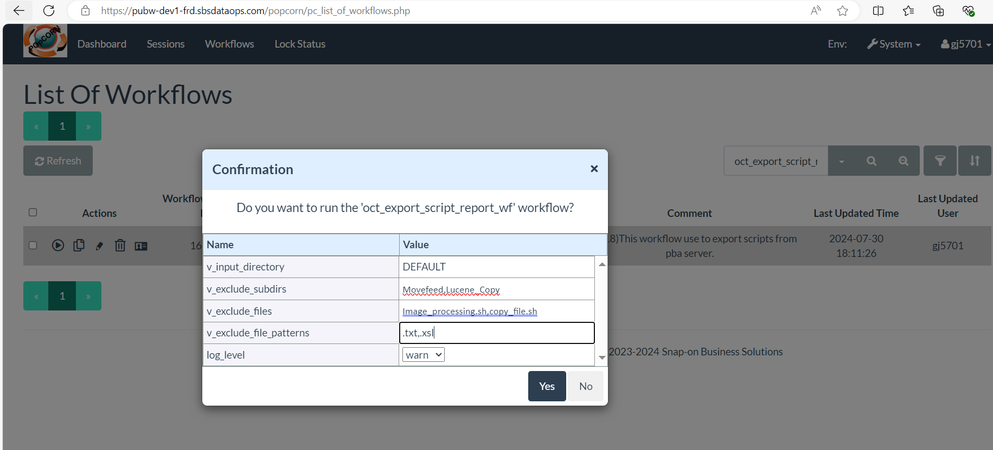
Exported scripts File received via email
Example: frd_dev_1_pba_003_rv_1.0.0.0_oct_script_export_20240816.csv
On Int:
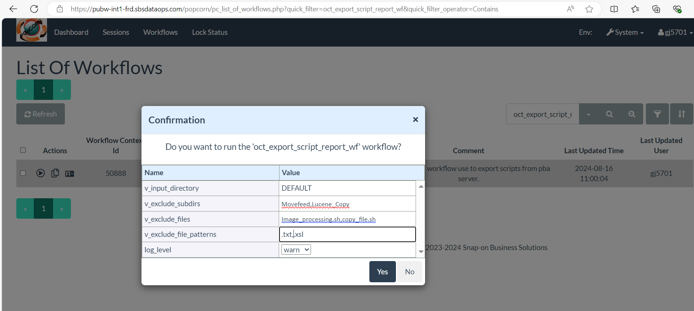
Exported DDL File received via email
Example: frd_int_1_pba_003_iv_1.0.0.0_oct_script_export_20240816.csv

1.1.2 DB Objects: Login to the popcorn screen on both the environment (ex: DEV&INT, INT&PRD, DEV&PRD etc.) and execute workflow oct_export_ddl_report_wf to export DDLs and Meta data from Database:

--------------------------------------------------------------------------------------------------------------------------------------
NOTE:

This workflow reads the db objects script and metadata as per input parameters and write them in the csv file, We will receive this csv file as an output via email.
Variable needs to be pass during this workflow execution(3):
schema_name: Executing workflow with schema_name value as ‘ALL’ will consider list of schema as defined in table pba_param_t with param_nm ‘OCT’;
"schema_ddl":"AF_REPO,BL,CTRG,CTRG_SUPPORT,HOSTING_SUPPORT,PUB_ADMIN,PUB_WORK,SBS_UTIL,SSCTRG,TRG_DS_FRD,TRG_DS_FRDHVY,BL_APP,PUB_ADMIN_APP,PUB_WORK_APP".
- "schema_ddl":" can be updated using PHP page.
- FYI, Comma separated schema_name is not allowed to pass through workflow while executing it. You can pass either ALL or a single schema name.

object_type: Executing workflow with object_type value as ‘ALL’ will consider list of object types defined in pba_param_t variable ‘OCT’;
"ddl_type":"CONTEXT_OPTIONS,FUNCTION,GRANTS,META_TABLE,PARTITION_NAME,PROCEDURE,SCHEMA_SIZE,TABLE,VIEW,WORKFLOW"
- "dd_type":" can be updated using PHP page.
- FYI, Comma separated object_type are not allowed to pass through workflow while executing it. You can pass either ALL or a single ddl_type.
object_name: Executing workflow with object_name value as ‘ALL’ then it will consider all objects based on input schema and object_type.
- FYI, Comma separated object_name is not allowed to pass through workflow while executing it. You can pass either ALL or a single object name.

Ensure passing the same input parameter on both the environment.
On Dev:
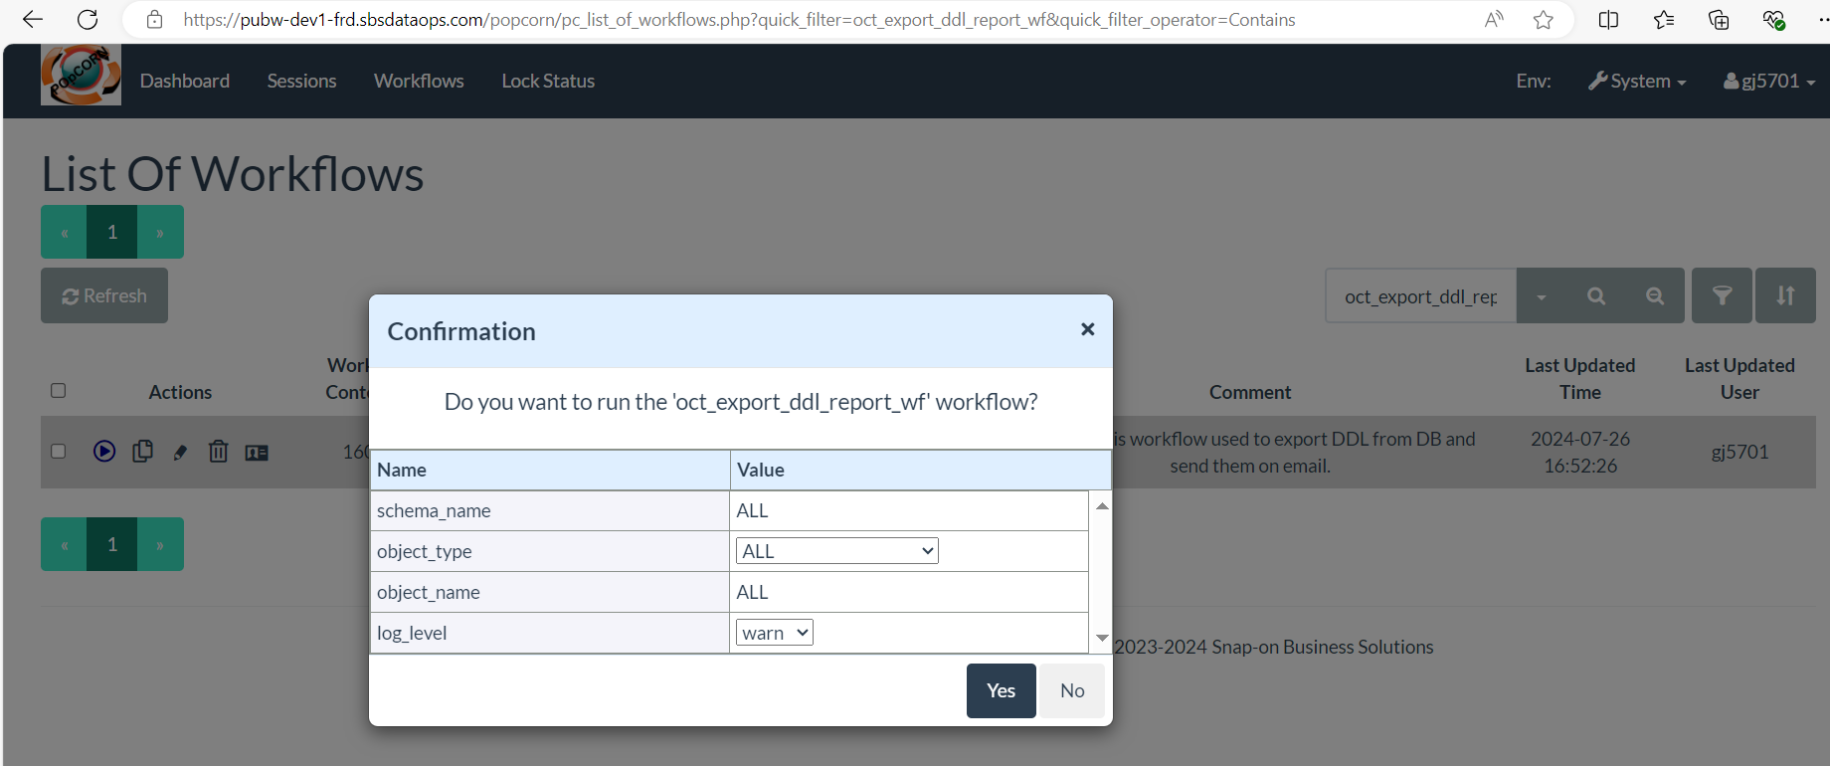
Output: frd_dev_1_oct_ddl_export_20240816.csv.gz received via email
On Int:
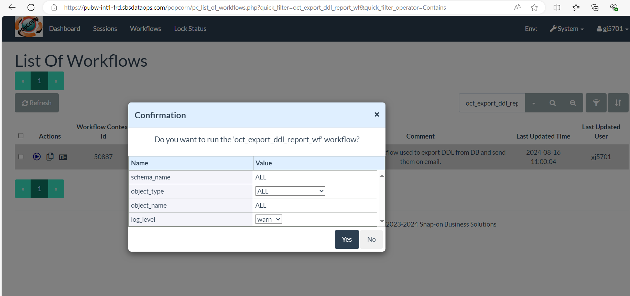
Output: frd_int_1_oct_ddl_export_20240816.csv.gz via mail.

Manual step:

FYI: If .gz extension on exported files received via email depends on their size. There's no need to unzip them; you can use the files as they are received, whether they are .csv or .csv.gz files.
- Copy File frd_dev_1_pba_003_rv_1.0.0.0_oct_script_export_20240816.csv and frd_dev_1_oct_ddl_export_20240816.csv.gz to /OCT/TIER1 directory on DEV environment
Example: /F/Ford/FRDCornerstone/EPO/OCT/TIER1
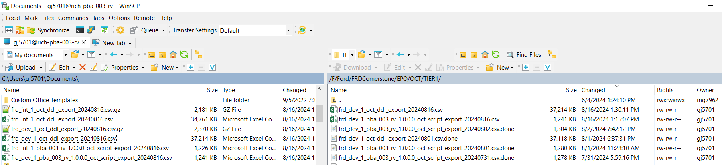

- Copy File frd_int_1_pba_003_iv_1.0.0.0_oct_script_export_20240816.csv and frd_int_1_oct_ddl_export_20240816.csv.gz to /OCT/TIER2 directory on DEV environment
Example: /F/Ford/FRDCornerstone/EPO/OCT/TIER2

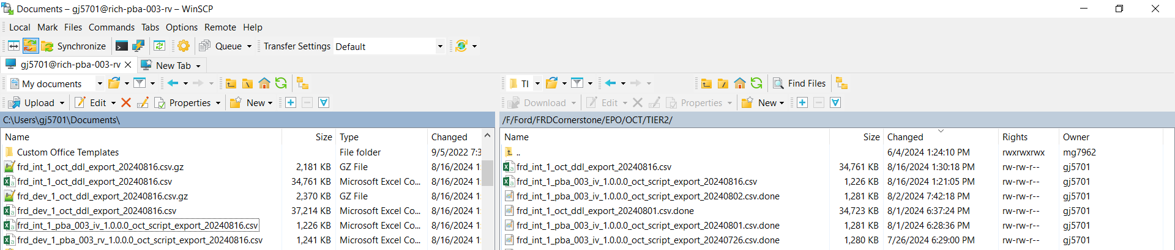

Execution of comparision workflow

Login to the popcorn screen on DEV environment and execute oct_master_comparison_wf workflow
--------------------------------------------------------------------------------------------------------------------------
Before executing this workflow, make sure that you have placed the files correctly in folder TIER1 & TIER2. and select appropriate v_comparison_of parameter.

NOTE:
This workflow loads file data from the TIER1 and TIER2 folders on the PBA server into the pub_work.oct_ddl_tier1 and pub_work.oct_ddl_tier2 tables on the DEV environment. It then compares the data between these two tables.
Upon successful execution, a .csv or .csv.gz file listing the objects with differences will be generated and sent via email.
v_comparison_of = [DDL:SCRIPT:BOTH], select one based on files available in folder TIER1 & TIER2
On Dev:
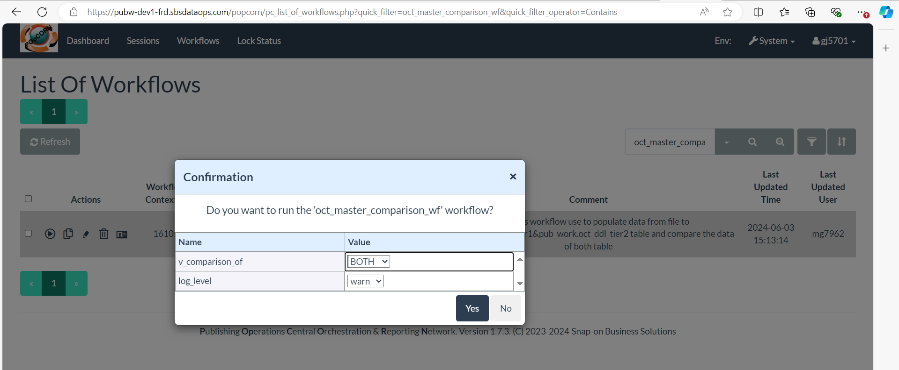

Output Example:
pba_003_rv_1.0.0.0_and_pba_003_iv_1.0.0.0_comparison_report_20240816.csv.gz and
frd_dev_1_and_frd_int_1_comparison_report_20240816.csv.gz
Unzip the output file if received in gz format:
Example: pba_003_rv_1.0.0.0_and_pba_003_iv_1.0.0.0_comparison_report_20240816.csv and frd_dev_1_and_frd_int_1_comparison_report_20240816.csv
User can check the csv file find the difference between the objects of Dev and INT Environment.

For any query/help, please contact:
bipin.kumar@snapon.com
richa.thakur@snapon.com
manish.khanna@snapon.com

****END****

